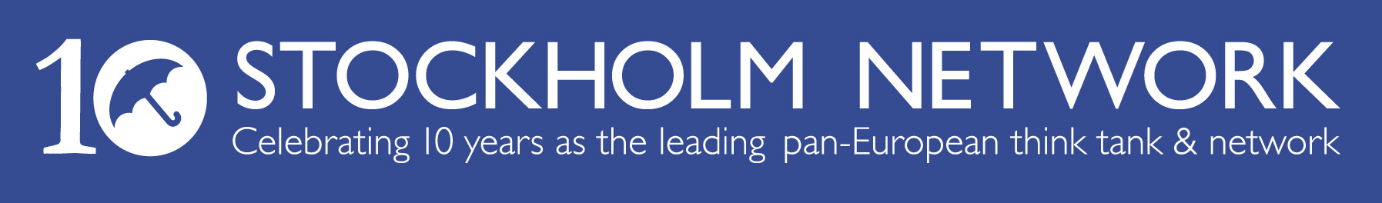
The Stockholm Network warmly invites
................................................
to attend a round table lunch co-hosted by
the Stockholm Network and Reform to discuss
‘Europe's Road Map to Reform’
on Thursday 8th March 2007 from 12:30 – 2:00pm
at the Reform Board Room, 45 Great Peter St, London SW1P 3LT
Many developed countries are in great need of free-market reform, not least in Europe, but very little is happening. Quite a few countries have, however, managed to do substantial reforms with great success. What should be done is no secret; the causes and solutions are well known. So why is so little actually happening? Which are the main obstacles? And most importantly, what and how did the successful ones do it? What would a reform strategy, based on their experience, today look like?

Following the success of ‘European Dawn’, author Johnny Munkhammar, Programme Director of Timbro will be discussing these questions and seeking expert feedback from the audience on policy reforms from across the EU.

RSVP: Cara Walker T: 020 7354 8888
cara@stockholm-network.org
Please advise if you have any dietary requirements.

